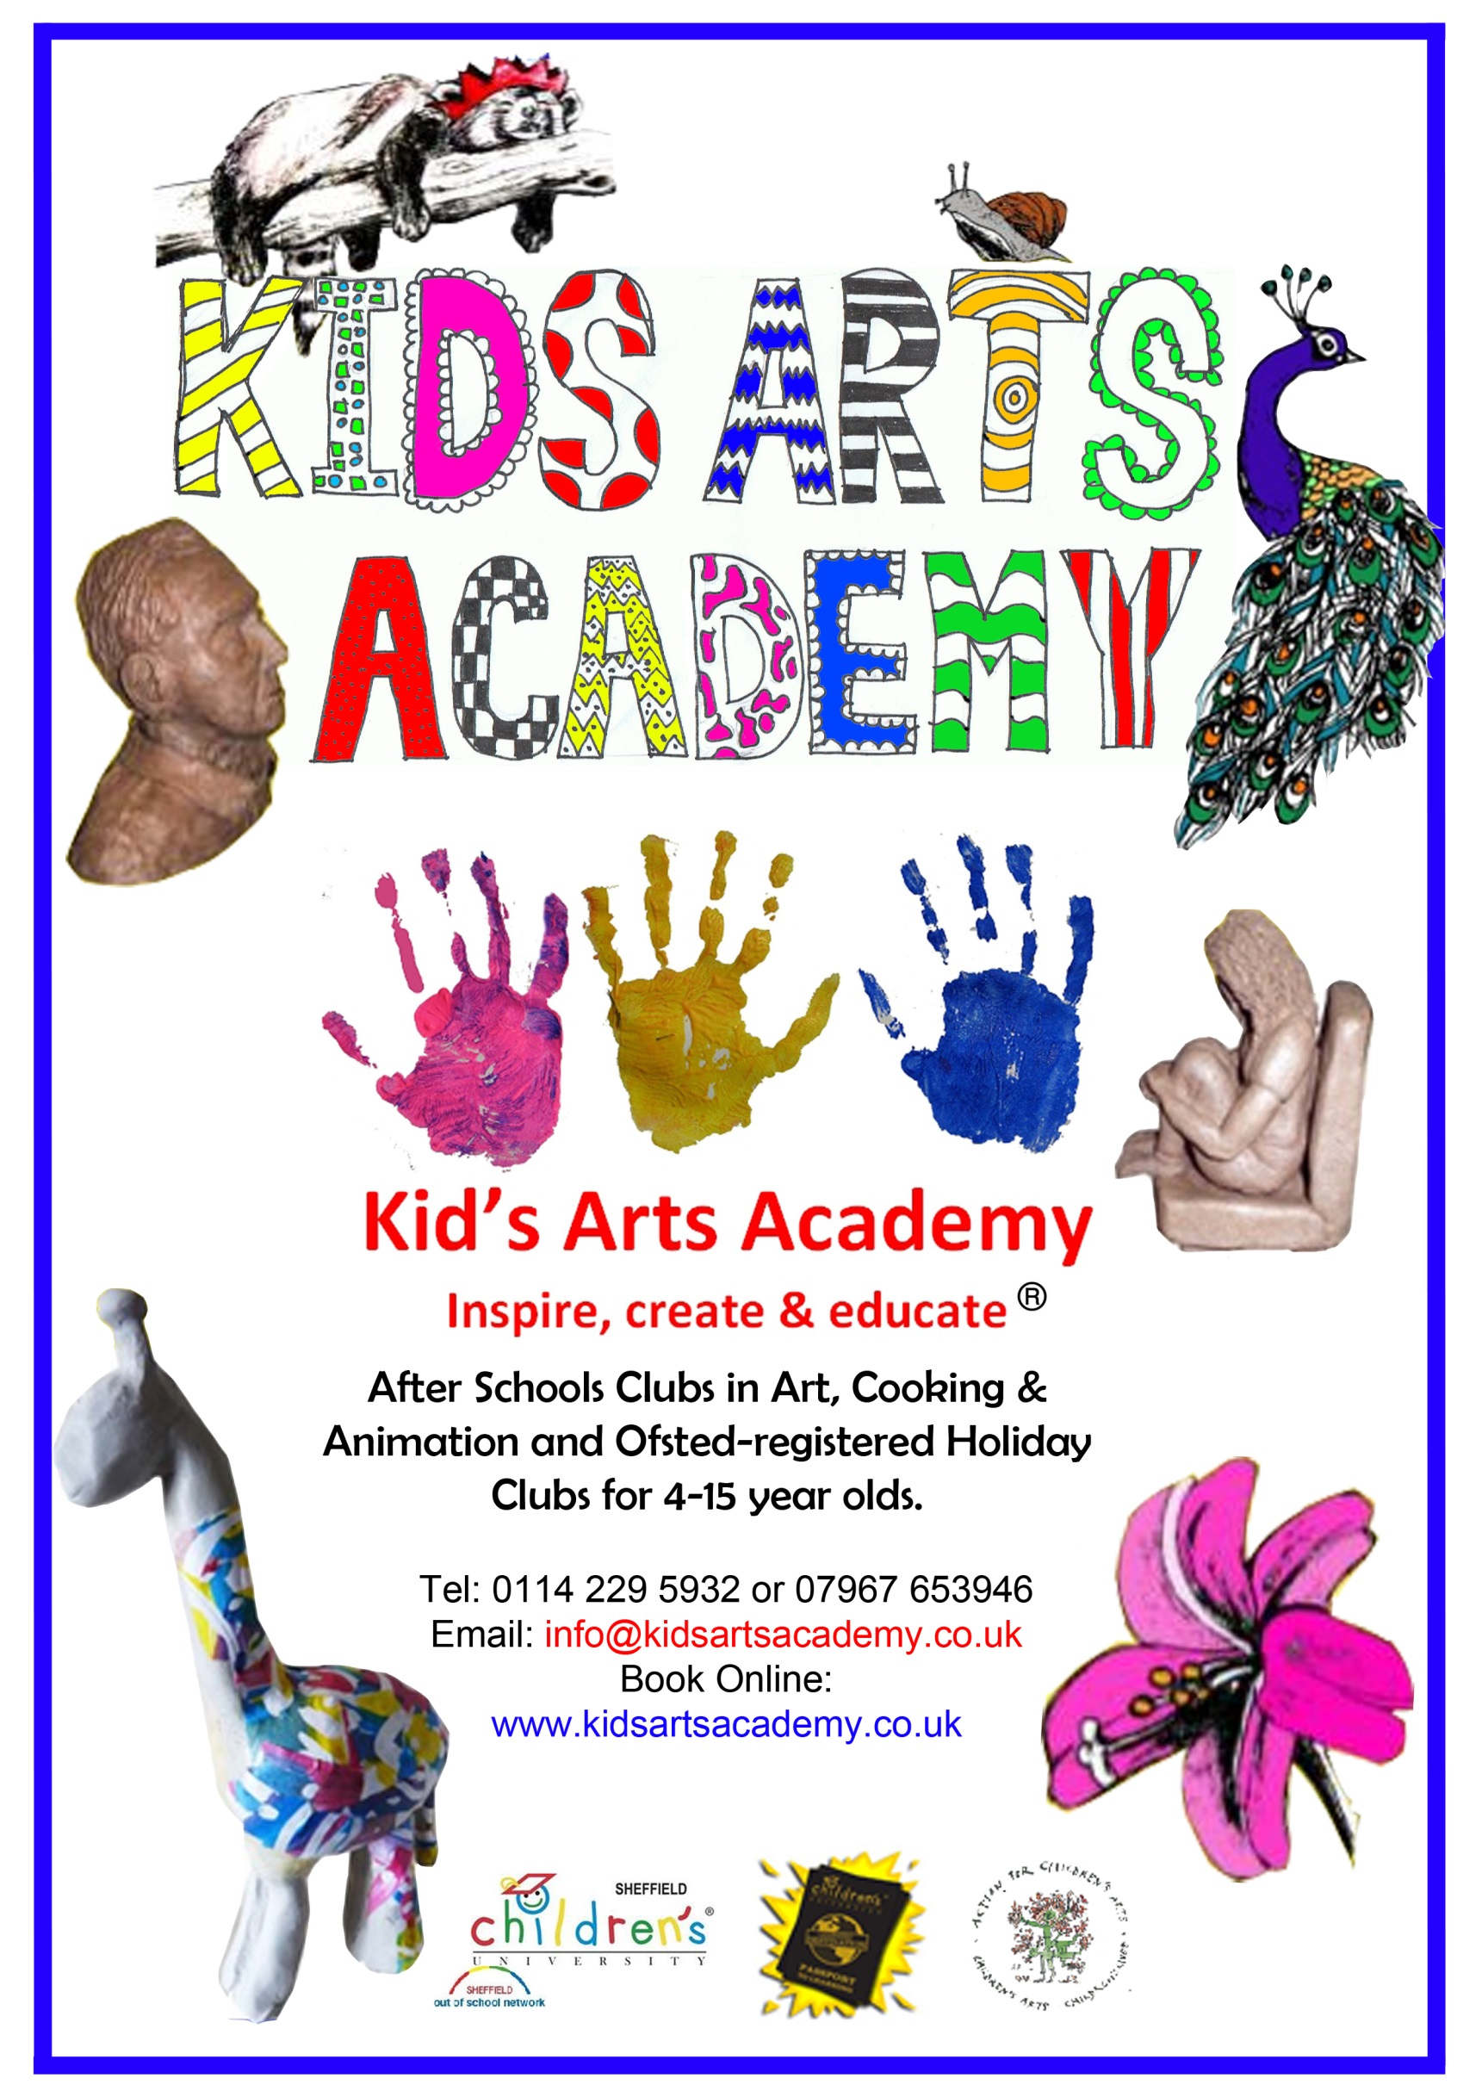
February Half-term Timetable 2015
Regular hours 10am-3.30pm Extended hours 8.30am to 5.30pm
Book Online at kidsartsacademy.co.uk
Art Timetable
 | AM | PM
Monday 16th Feb | Printing activity | Learn to draw a Fort
Tuesday 17th Feb | Circle Loom Weaving | Learn to draw an eagle
Weds. 18th Feb | How to draw Manga ( Japanese style cartoons) & make a Manga Mask | Picasso Inspired Painting
Thursday 19th Feb | Make a clay alien | Learn to draw the Taj Mahal
Friday 20th Feb | Fabric Painting | How to draw an Ogre
Cooking Timetable (All our recipes are meat free)
 | AM | PM
Monday 16th Feb | Spaghetti Bolognese | Peach and Pear Flumble
Tuesday 17th Feb | Calzone | Chocolate and Orange Cake
Weds. 18th Feb | Make your own Pasta ( and sauce) | Choc chip cookies
Thursday 19th Feb | Veggie Lasagna | Double Chocolate Brownies
Friday 20th Feb | Tomato and Herb Bread | Bakewell Pudding
Animation Timetable
 | AM | PM
Monday 16th Feb | 4-8 Yr Olds: Amazing Alien Adventure | 4-8 Yr Olds: Amazing Alien Adventure
Weds. 18th Feb | 9-14 Yr Olds: Amazing Alien Adventure | 9-14 Yr Olds: Amazing Alien Adventure
Friday 20th Feb | 4-8 Yr Olds: An Underwater Adventure | 4-8 Yr Olds: An Underwater Adventure
Visit www.kidsartsacademy to see our holiday dates for the rest of 2015 – We are open every school holiday!
Book Online at kidsartsacademy.co.uk
All materials and ingredients are provided, and everything made is taken home by the children.
To receive updates about our after school and Ofsted registered holiday club activities subscribe to our mailing list at www.kidsartsacademy.co.uk
All activity info about our after school clubs and Ofsted registered holiday clubs is available on the website.
Come and get crafty with us at the Kids Arts Academy
Company Number 06506934

